One of the great ministries of Exodos is providing work

opportunities for local and state entities who struggle

to find willing hosts to provide job experience, training and volunteer hours. Exodos cooperates with:

*County Probation

*State Probation

*Caucus on the Black & Aging

*Richbourg School

*Re-employability

*DCF Work-fare program

*All local highschools

*And many more

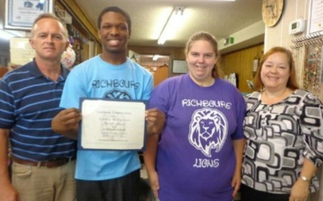

NEW EXODOS BOARD MEMBERS

Praise God! He has blessed our Board with two new members. Please pray for wisdom for our Exodos team.

Russell Moorman is the owner of AAA Waste and a leader at Woodlawn Baptist Church. Bob Champion is a civilian employee on Eglin Air Force Base and a retired Air Force Officer. Bob is a leader at Mosaic Church.

When people thank us for meeting their needs at Exodos we always say, “It’s not our stuff! Everything belongs to our Father and He owns the cattle on a thousand hills!!!!” We trust Him to supply and He does. Nonetheless, we have to admit that from time to time we scratch our heads and wonder why it seems like we give away even more than we sell. Recently, we found out that we really are the ONLY clothing store or Thrift store locally that accepts vouchers for clothing the disadvantaged. Therefore, the need is great! We need your partnership! Please do not neglect to pray for us, “That when (we) open our mouths, words might be given us to fearlessly make known the mysteries of the gospel.” – Ephesians 6:19 Also, please ask God how He might want you to help with material and/or financial donations or the gift of your time as a volunteer.

The following entities write vouchers and send needy folks to us: **\*H.O.P.E. Network** **\* Sharing & Caring**

**\*Bridgeway Center *Lutheran services of Florida**

**\*All local churches *All Probation offices**

**\*Crestview Area Shelter for the Homeless**

**\*Okaloosa County Dept. of Corrections**

**\*Okaloosa Correctional Institute**

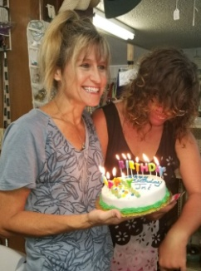

One of our friends told us recently that when he is hot or extremely cold and has “nowhere else to go”, we are the only people who let him come inside and find shelter. When we surprised him for his birthday, we found out he’d never had a cake with his name on it before. Please help us show the love of Christ to hurting folks! Give today.

God’s word admonishes us to be kind to all that we encounter and, “Don’t forget to welcome outsiders. By doing so, some people have welcomed angels without knowing it” – Hebrew 13:2. We do our best to love on all the folks who come to us for help, prayer and safe harbor.



We like to leave blankets outside for our homeless friends. Please donate any warm blankets that you can spare.

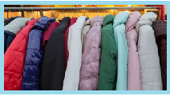

Due to the fact that Hurricane Michael and Winter temps arrived about the same time, we are out of coats and jackets! Not only do we have local customers who need jackets, we also serve the homeless and down trodden through our voucher program. When temperatures drop, our friends in need flood in for physical warmth and it gives an opportunity to meet spiritual needs too. Furthermore, we have many folks displaced from the hurricane. Please help us by donating your warm coats, jackets and clothing.



JANUARY 2019

