Thank you for your faithful support of Exodos Ministries. I thought it appropriate to introduce you to one of the fellas your contributions are ministering to during this season:
A few months ago a young man shyly stepped into the sorting shed where I was working at our ministry Thrift Store. He was skin and bones and had ”the look” of fear and hunger. He shyly said, “Ma’am, I’ve been living on the streets and doing drugs and somebody told me I could come to you and you will help me stop living this way.” I stepped out of the dimly lit shed onto the porch and toward the young man. In the light of day, I saw in that young man’s face, a little boy I had once known and prayed for. Fifteen years earlier, a little boy had shown up at our community ballpark with an older couple who had just adopted him and his two older brothers. The adoptive parents had been watching the local news when a plea was made to secure adoption for 3 brothers that were about to be split up. They answered the plea, adopted the boys and had enrolled them in our local baseball program and school. I befriended those little scared boys, prayed for them, furnished their first cleats and other needs…all those years ago and regularly shared the gospel with them and their adoptive parents.
Years passed and both of the two older brothers got into various troubles and ran away, so the adoptive parents GAVE the youngest son BACK to the state of Florida. I did not even know that was possible!! Unfortunately, it all happened before I knew a thing about it. I often wished I had known and had been offered the opportunity to take the boys myself. I often wondered what had happened to these boys who so badly needed unconditional love.
Now fifteen years later, the youngest brother stood before me on our ministry porch. I looked into that young man’s face and saw the little boy. I replied, “Oh my goodness! Your name is ‘Trent’ and I have loved you since you were 7! I have wondered about you and prayed for you and now God has brought you to me. Of course, we will help you. God has ordained this meeting!” Then, I threw my arms around the bewildered, homeless, motherless kid and welcomed him into our ministry family.
After “Trent” had been living at our ministry house for about a week under the love and supervision of our household supervisors Paul and Albert…and spending quality time with our family, “Trent” approached my husband with a precious question. He timidly asked, “You and Kyra and all your sons keep saying I am part of your family forever and that when I finish rehab I will still be a part of this family. I’ve lived in 21 foster homes and even been adopted once, but nobody ever let me call them mom and dad. Am I allowed to call you two, ‘Mom’ and ‘Dad’? “My husband assured this lonesome boy that we would surely be honored and now he calls me, “Mama” one hundred times a day!
What a JOY when our heavenly Father adds to our family!!!! It reminds me that it is the job of every Christian and church family to love in such a way that lost and hurting people WANT to join our family of faith and long to call OUR Heavenly Father, “Daddy”!
“Trent” is just one example of the privilege we have at Exodos to love people to Christ through our recovery home and our Thrift Store. Please pray for: our wisdom, discernment and divine appointments; the hearts of those we minister to and the provision to accomplish God’s purposes. Thank you again for being a part of that provision.
God bless,
Kyra
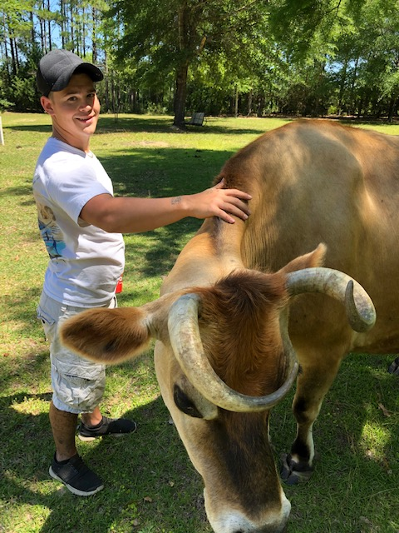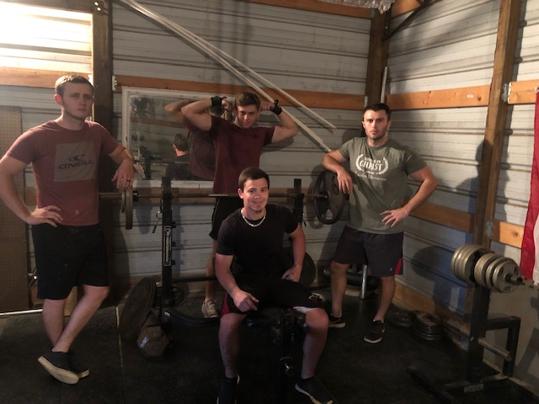
“Trent” with Sirloin the Cow “Trent” with his new brothers

