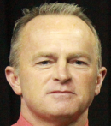
TOM CROWSON’S TESTIMONY

Dear friends:
Two years ago, a friend who was concerned about
my intake of Aspirin (due to all my back surgeries) suggested I try a more gentle and “natural pain-killer”. The product is called Krave and at that time could be purchased over the counter at any drug store, Wal-mart or convenience store as an herbal remedy. It seemed to me like a sensible non-narcotic substitute for Aspirin which was destroying my stomach. I tried it and it worked great for a while.
The problem came when I realized last year that I was addicted to this product. There were not strict guidelines for use (only suggestions) and, I came to find out later, dangerous side-effects. Furthermore, upon much research, we found that though many practitioners were recommending it as a non-narcotic alternative to painkillers, the “FDA does not monitor the safety or purity of herbs” (Healthline). Therefore, there are dangers to this product that are NOT on the label. Addiction is only one danger. Please stay away from this product and warn those you love.
Needless to say 2018 was a hard year for my family and Exodos ministries. When I realized that I actually had a terrible addiction to this product I stepped away from my position as director of Exodos to pursue my own recovery. At the time, all seemed hopeless that after a decade of avoiding ALL narcotics and anything that might ensnare me, I had fallen into an addiction trap again! However, God kept reminding me that He only allows Satan to sift believers to accomplish His purposes. Remember when Jesus said to Simon Peter, “Satan has asked to sift you as wheat. But I (Jesus) have prayed for you…that your faith may not fail. And when you have turned back, strengthen your brothers.” (Luke 22:31-32)
I have learned so much more about addiction and recovery. I want to “strengthen my brothers” and be a part of leading the lost to Christ with these lessons. I went on a terrible field trip, but God used my weaknesses to show His strength as always! I was reminded anew about Satan’s scheming and the traps he uses to destroy lives. While other recovery centers are just beginning to learn about this new trick Satan has up his sleeve, Exodos has the inside scoop though it came at a HUGE price to my family, the ministry and me. Please pray with me that God will show me how to best use what I’ve learned to help other men avoid the hidden landmines of addiction that are also buried beneath legal and “natural” remedy labels.
Please pray for Exodos as we are restructuring our board, residential supervising and pastoral presence on site, as well as discerning the role God wants me to play. We are excited to watch God take what “Satan wanted for evil and use it for the SAVING of many lives!” (Genesis 50:20)

Brother Clyde Risen faithfully served as our On-site Pastor at Exodos Recovery Ministry for nearly a decade. He and his wife Connie have been a blessing from the Lord to all. Though Brother Clyde would assure you that pastors “never retire”, he has promised to slow down. He and Ms. Connie would appreciate your prayers as they enjoy a “new season” in life. They have moved a few miles down the road to enjoy a new chapter.

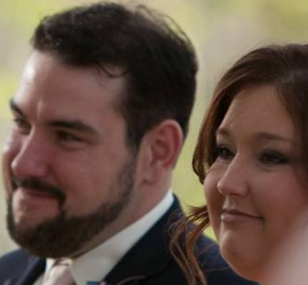
Donald Way, who served as our Men’s House Supervisor has been blessed with a beautiful bride. Wow! God is good! Pray for Donald and Laura as they begin their new life serving the Lord as one. Exodos needs your prayers as we welcome a new team of both new house supervisor and on-site pastor.
ATTENTION:
We will be remodeling our on-site pastor’s house. We need co-laborers in Christ. Please consider making some of these tasks a ministry project from your church. Please call to volunteer your skills to make this happen:
850-398-2910 or
850-902-1787

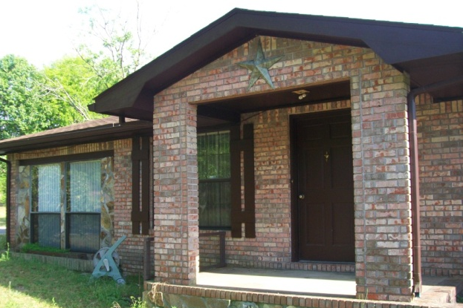
For recovery help call: 850-398-2910 or 850-902-1787

To Donate Items or volunteer at Thrift Store call: 850-682-1511

To make a tax free financial contribution:
PO Box 1710, Crestview, FL 32536 or
Use PayPal at: www.exodosministries.com
Or…drop by our Thrift Store at 696 North Ferdon in Crestview

